Table of Contents

Risk Reversals – Guarantees 2
Video Scripts 3
Press Release Sample 9
Funeral Buying Keywords (Mail Merge Ready) 11
Cremation Buying Keywords (Mail Merge Ready) 14
Negative Keywords 15
Google AdWords Ads (Costs) 16
Sample Print Ads 17
Yellow Page Ad Makeover 18
3 Website & Obituary Traffic Strategies – Swipe Copy 20
4 Step Letter Sample – Fundraising 22
Preneed Video Scripts 23
Resource Kit: What To Do If A Death Has Occurred 26
Resource Kit: Funeral Planning Checklist 28
Resource Kit: Funeral / Celebration of Life Planning Checklist 29
Resource Kit: Obituary Submission Guidelines 30
Resource Kit: A Celebration of One’s Life 31

Risk Reversal - Guarantees

100% Service Guarantee
«Funeral_Home» is committed to service beyond expectation before, during and after the service. We guarantee that if you are not 100% satisfied with any aspect of our service, we will make every effort to correct the situation. If we cannot correct it to your satisfaction, you will not be charged for that particular service item.

No Hidden Fee Guarantee
Funeral and Cremation costs can be very confusing. Often times other funeral & cremation providers will quote what seems like a low price, but actually they do not give you the complete costs and there will be hidden add on charges after you have chosen to utilize their services. We have made it easier to understand by creating our “No Hidden Fee Guarantee” package plans.

These plans include :
- Service Fees
- Merchandise
- Cremation or Cemetery fees
- Cash Advance items
- Taxes

We guarantee that the price we give you over the phone or you see on this site, will be the price that you will pay.

Cash advance items and cemetery expenses are not included: What some funeral homes fail to disclose are the additional fees that may be necessary. These include cemetery expenses, obituaries, honorariums (clergy, musicians, soloists, altar servers), catering, sales tax, etc. We will be more than happy to email you a quote so that you will have an estimate that is as accurate as possible.

Video Scripts

TITLE: «City» Funeral Costs Made Simple | Funeral Homes in «City», «State»

If you are looking for information about how much Funeral services cost in «City», «State», we know that it can be quite confusing, that’s why at «Funeral_Home», we make understanding Funeral costs simpler and that is why created our Funeral Costs Calculator and our No Hidden Fee Guarantee.
Let me explain... (next slide)

We have made it easier to understand by our Funeral Cost Calculator. There are just 5 simple steps so that you can get the complete costs… with No Hidden Fees!
(next slide)

And that brings me to our No Hidden Fee Guarantee. We guarantee that the price we give you over the phone will be the price that you will pay – with No Hidden Fees!
(next slide)

For More Information... Call our helpful staff to answer any other questions you may have about Funeral and the Cremation services we offer. «Work_Phone» or visit our website at «Website_URL»/funeral-costs.

TITLE: «City» Cremation Costs Made Simple | Cremation in «City», «State»

If you are looking for information about how much Cremation services cost in «City», «State», we know that it can be quite confusing, that’s why at «Funeral_Home», we make understanding Cremation costs simpler and that is why created our Cremation Costs Calculator and our No Hidden Fee Guarantee.

Let me explain... (next slide)
We have made it easier to understand by our Cremation Cost Calculator. There are just 5 simple steps so that you can get the complete costs… with No Hidden Fees!
(next slide)

And that brings me to our No Hidden Fee Guarantee. We guarantee that the price we give you over the phone will be the price that you will pay – with No Hidden Fees!
(next slide)

For More Information... Call our helpful staff to answer any other questions you may have about Funeral and the Cremation services that we can assist you with at «Work_Phone» or visit our website at «Website_URL»/cremation-costs.

TITLE: Funeral Homes in «City», «State» | Choosing a «City» Funeral Home

Are you in need of a funeral home in «City», «State»?

We understand that there are a lot of choices to make when planning a funeral and that it can be quite confusing...

To help you get started, we at «Funeral_Home», have made a number of free resources available to you on our website at: «Website_URL»
(next slide)

We have created a free Funeral & Cremation Resource Kit which includes:
- What to Do Next: Step by Step Guide
- Funeral & Cremation Planning Checklist
- Funeral & Cremation Planning Form
- Obituary Submission Guidelines
- Service Personalization Worksheet
This valuable resource is free to download at «Website_URL»/resource-kit
(next slide)

Also I wanted to mention to you our Double Guarantee.

The first is our No Hidden Fee Guarantee. We know that Funeral and Cremation costs can be very confusing. Often times other funeral & cremation providers will quote what seems like a low price, but actually they do not give you the complete costs and there will be hidden add on charges after you have chosen to utilize their services. We have made it easier to understand by creating our “No Hidden Fee Guarantee”

We guarantee that the price we give you over the phone, by email or that you see on this site, will be the price that you will pay – with No Hidden Fees.

The second is our Service Satisfaction Guarantee.
We are committed to service beyond expectation before, during and after the service. We guarantee that if you are not 100% satisfied with any aspect of our service, we will make every effort to correct the situation. If we cannot correct it to your satisfaction, you will not be charged for that particular service item.
(next slide)

To find out more about how we can offer the personal touch for the funeral services that you have to arrange, please visit our informational website at «Website_URL».
You can browse our guides, watch our videos and download our free funeral planning resources at your leisure.

If at any time you have any specific questions, please call us at «Work_Phone» and we will be glad to help you.

TITLE: Cremation in «City», «State» | Choosing a «City» Cremation Service

Are you in need of a cremation service in «City», «State»?

We understand that there are a lot of choices to make when planning a cremation and that it can be quite confusing...

To help you get started, we at «Funeral_Home», have made a number of free resources available to you on our website at: «Website_URL»
(next slide)

We have created a free Funeral & Cremation Resource Kit which includes:
- What to Do Next: Step by Step Guide
- Funeral & Cremation Planning Checklist
- Funeral & Cremation Planning Form
- Obituary Submission Guidelines
- Service Personalization Worksheet
This valuable resource is free to download at «Website_URL»/resource-kit
(next slide)

Also I wanted to mention to you our Double Guarantee.

The first is our No Hidden Fee Guarantee. We know that Funeral and Cremation costs can be very confusing. Often times other funeral & cremation providers will quote what seems like a low price, but actually they do not give you the complete costs and there will be hidden add on charges after you have chosen to utilize their services. We have made it easier to understand by creating our “No Hidden Fee Guarantee”

We guarantee that the price we give you over the phone, by email or that you see on this site, will be the price that you will pay – with No Hidden Fees.

The second is our Service Satisfaction Guarantee.
We are committed to service beyond expectation before, during and after the service. We guarantee that if you are not 100% satisfied with any aspect of our service, we will make every effort to correct the situation. If we cannot correct it to your satisfaction, you will not be charged for that particular service item.
(next slide)

To find out more about how we can offer the personal touch for the cremation services that you have to arrange, please visit our informational website at «Website_URL».
You can browse our guides, watch our videos and download our free cremation planning resources at your leisure.

If at any time you have any specific questions, please call us at «Work_Phone» and we will be glad to help you.

Local Funeral Home Expands Obituary Notification Efforts in light of Newspaper Reducing Publications
City - State / Province - In a response to the local [Name of Newspaper] newspaper’s decision to reduce the number of publications to 4 days per, the [NAME] Funeral Home has taken it upon itself to make sure that the public is informed as quickly as possible about upcoming funeral service times. http://www.YourFuneralChapel.com
Funeral Director, [Name] says, “That since the [Name of Newspaper] has made these cost cutting measures to reduce expenditures it has also made it difficult to inform the public about funeral times. That is why we have taken the responsibility to do so with the creation of our Obituary Notification System.”
The [NAME] Funeral Home has implemented five new systems to inform as many members of the [CITY] community as possible of upcoming funeral service information.
The www.YourFuneralChapel.com website has been created to notify Google and the other search engines immediately once an obituary notice has been added to the website. This will allow people who are searching for the deceased’s name to find the funeral service information quicker. In as little as fifteen minutes from the time the obituary has been added to the website, people can Google the deceased’s name and find the obituary and funeral information.
The Obituary Email Notification Service allows members of the public to enter and confirm their email address and then will receive a daily email with any new obituary notices in the evening and if there are not any new obituaries, they will not receive any notifications.
The next two new Obituary Notification features are for users of Social Media. As soon as the obituary is added to website, a tweet is sent to the funeral home’s Twitter account (@[FuneralHome]) so that followers on Twitter can receive the obituary information. The same is true for Facebook as a link is automatically sent to the funeral home’s Facebook page.
The last enhancements to our Obituary Notification System are the “Share Obituary” features. One of which is an email form which is similar to a “Tell A Friend” website form. This is where one reader of the online obituary can easily email it to a friend who may not be aware of the funeral. For those who connect via Social Media, each obituary has ‘Share’ buttons at the bottom so that the reader can share the information through Facebook, Twitter, Google+ and other social channels.
“It is amazing how many members of the [CITY] community use these features. Most people come to our obituaries from a Google search and secondly through Facebook. We have also found that a lot of people who have moved away from [CITY] use one of the subscription services, such Email, Facebook or Twitter to stay connected to their home town - this applies to snowbirds as well.” added [FD Name]
[FD Last Name] also noted that they have started to add the Memorial Tribute videos to the obituary through YouTube so that those who were not able to attend the service can still see the deceased’s pictorial tribute. In the condolences left by visitors, many people reference the video tribute.
To see all of the features of [Funeral Home Name]’s Obituary Notification System, visit http://www.YourFuneralChapel.com/obituaries
About [Funeral Home Name]
Since [START YEAR], the family-owned and operated [Funeral Home Name], located in [CITY], has been serving the residents of [GREATER AREA] with care, compassion and consideration.
The [Funeral Home Name] is recognized in the funeral profession as a leader technology and online services. [Add additional information if needed]
Contact Information:
[Name]
[Phone #]
[Email Address]

Funeral Buying Keywords

cost of a funeral
cost for a funeral
cost of funeral
cost for funeral
the cost of a funeral
cost funeral
funeral cost
price of funeral
price funeral
price of a funeral
funeral price
costs of a funeral
costs of funeral
funeral costs
cost of a funeral and burial
cost of funeral and burial
funeral and burial costs
funeral burial costs
cost of funeral expenses
funeral prices
funeral home cost
average cost funeral
cost of average funeral
average cost for funeral
the average cost of a funeral
average cost for a funeral
cost of an average funeral
average funeral cost
average cost of funeral
funeral average cost
funeral cost average
average cost of a funeral
what is the average funeral cost
average cost of funeral and burial
average price of a funeral
average price for a funeral
average price of funeral
what does a funeral cost
average funeral costs
funeral costs average
how much is a funeral cost
how much a funeral cost
how much is funeral cost
how much funeral cost
how much does a funeral cost
how much does funeral cost
average cost of funeral expenses
how much should a funeral cost
how much will a funeral cost
funeral homes prices
funeral home prices
prices funeral home
funeral costs assistance
funeral home costs
funeral cost assistance
cost of a cremation funeral
cost of funeral cremation
funeral price list
cremation funeral costs
funeral costs cremation
funeral cremation costs
funeral cost insurance
low cost funeral
funeral costs insurance
cost of funeral services
cost of funeral service
funeral service cost
cost of a funeral service
funeral home price list
funeral services costs
funeral general price list
funeral service prices
funeral service costs
funeral services prices
what does the average funeral cost
funeral home general price list
general price list for funeral homes
funeral cost breakdown
funeral costs breakdown
breakdown of funeral costs
how much is funeral cost
how much funeral cost
how much does a funeral cost
how much does funeral cost
average cost of funeral expenses
how much should a funeral cost
how much will a funeral cost
funeral homes prices
funeral home prices
prices funeral home
funeral costs assistance
funeral home costs
funeral cost assistance
cost of a cremation funeral
cost of funeral cremation
funeral price list
cremation funeral costs
funeral costs cremation
funeral cremation costs
funeral cost insurance
low cost funeral
funeral costs insurance
cost of funeral services
cost of funeral service
funeral service cost
cost of a funeral service
funeral home price list
funeral services costs
funeral general price list
funeral service prices
funeral service costs
funeral services prices
what does the average funeral cost
funeral home general price list
general price list for funeral homes
funeral cost breakdown
funeral costs breakdown
breakdown of funeral costs

cost of a funeral «City»
cost for a funeral «City»
cost of funeral «City»
cost for funeral «City»
the cost of a funeral «City»
cost funeral «City»
funeral cost «City»
price of funeral «City»
price funeral «City»
price of a funeral «City»
funeral price «City»
costs of a funeral «City»
costs of funeral «City»
funeral costs «City»
cost of a funeral and burial «City»
cost of funeral and burial «City»
funeral and burial costs «City»
funeral burial costs «City»
cost of funeral expenses «City»
funeral prices «City»
funeral home cost «City»
average cost funeral «City»
cost of average funeral «City»
average cost for funeral «City»
the average cost of a funeral «City»
average cost for a funeral «City»
cost of an average funeral «City»
average funeral cost «City»
average cost of funeral «City»
funeral average cost «City»
funeral cost average «City»
average cost of a funeral «City»
what is the average funeral cost «City»
average cost of funeral and burial «City»
average price of a funeral «City»
average price for a funeral «City»
average price of funeral «City»
what does a funeral cost «City»
average funeral costs «City»
funeral costs average «City»
how much is a funeral cost «City»
how much a funeral cost «City»
how much is funeral cost «City»
how much funeral cost «City»
how much does a funeral cost «City»
how much does funeral cost «City»
average cost of funeral expenses «City»
how much should a funeral cost «City»
how much will a funeral cost «City»
funeral homes prices «City»
funeral home prices «City»
prices funeral home «City»
funeral costs assistance «City»
funeral home costs «City»
funeral cost assistance «City»
cost of a cremation funeral «City»
cost of funeral cremation «City»
funeral price list «City»
cremation funeral costs «City»
funeral costs cremation «City»
funeral cremation costs «City»
funeral cost insurance «City»
low cost funeral «City»
funeral costs insurance «City»
cost of funeral services «City»
cost of funeral service «City»
funeral service cost «City»
cost of a funeral service «City»
funeral home price list «City»
funeral services costs «City»
funeral general price list «City»
funeral service prices «City»
funeral service costs «City»
funeral services prices «City»
what does the average funeral cost «City»
funeral home general price list «City»
general price list for funeral homes «City»
funeral cost breakdown «City»
funeral costs breakdown «City»
breakdown of funeral costs «City»
how much is funeral cost «City»
how much funeral cost «City»
how much does a funeral cost «City»
how much does funeral cost «City»
average cost of funeral expenses «City»
how much should a funeral cost «City»
how much will a funeral cost «City»
funeral homes prices «City»
funeral home prices «City»
prices funeral home «City»
funeral costs assistance «City»
funeral home costs «City»
funeral cost assistance «City»
cost of a cremation funeral «City»
cost of funeral cremation «City»
funeral price list «City»
cremation funeral costs «City»
funeral costs cremation «City»
funeral cremation costs «City»
funeral cost insurance «City»
low cost funeral «City»
funeral costs insurance «City»
cost of funeral services «City»
cost of funeral service «City»
funeral service cost «City»
cost of a funeral service «City»
funeral home price list «City»
funeral services costs «City»
funeral general price list «City»
funeral service prices «City»
funeral service costs «City»
funeral services prices «City»
what does the average funeral cost «City»
funeral home general price list «City»
general price list for funeral homes «City»
funeral cost breakdown «City»
funeral costs breakdown «City»
breakdown of funeral costs «City»

«City» cost of a funeral
«City» cost for a funeral
«City» cost of funeral
«City» cost for funeral
«City» the cost of a funeral
«City» cost funeral
«City» funeral cost
«City» price of funeral
«City» price funeral
«City» price of a funeral
«City» funeral price
«City» costs of a funeral
«City» costs of funeral
«City» funeral costs
«City» cost of a funeral and burial
«City» cost of funeral and burial
«City» funeral and burial costs
«City» funeral burial costs
«City» cost of funeral expenses
«City» funeral prices
«City» funeral home cost
«City» average cost funeral
«City» cost of average funeral
«City» average cost for funeral
«City» the average cost of a funeral
«City» average cost for a funeral
«City» cost of an average funeral
«City» average funeral cost
«City» average cost of funeral
«City» funeral average cost
«City» funeral cost average
«City» average cost of a funeral
«City» what is the average funeral cost
«City» average cost of funeral and burial
«City» average price of a funeral
«City» average price for a funeral
«City» average price of funeral
«City» what does a funeral cost
«City» average funeral costs
«City» funeral costs average
«City» how much is a funeral cost
«City» how much a funeral cost
«City» how much is funeral cost
«City» how much funeral cost
«City» how much does a funeral cost
«City» how much does funeral cost
«City» average cost of funeral expenses
«City» how much should a funeral cost
«City» how much will a funeral cost
«City» funeral homes prices
«City» funeral home prices
«City» prices funeral home
«City» funeral costs assistance
«City» funeral home costs
«City» funeral cost assistance
«City» cost of a cremation funeral
«City» cost of funeral cremation
«City» funeral price list
«City» cremation funeral costs
«City» funeral costs cremation
«City» funeral cremation costs
«City» funeral cost insurance
«City» low cost funeral
«City» funeral costs insurance
«City» cost of funeral services
«City» cost of funeral service
«City» funeral service cost
«City» cost of a funeral service
«City» funeral home price list
«City» funeral services costs
«City» funeral general price list
«City» funeral service prices
«City» funeral service costs
«City» funeral services prices
«City» what does the average funeral cost
«City» funeral home general price list
«City» general price list for funeral homes
«City» funeral cost breakdown
«City» funeral costs breakdown
«City» breakdown of funeral costs
«City» how much is funeral cost
«City» how much funeral cost
«City» how much does a funeral cost
«City» how much does funeral cost
«City» average cost of funeral expenses
«City» how much should a funeral cost
«City» how much will a funeral cost
«City» funeral homes prices
«City» funeral home prices
«City» prices funeral home
«City» funeral costs assistance
«City» funeral home costs
«City» funeral cost assistance
«City» cost of a cremation funeral
«City» cost of funeral cremation
«City» funeral price list
«City» cremation funeral costs
«City» funeral costs cremation
«City» funeral cremation costs
«City» funeral cost insurance
«City» low cost funeral
«City» funeral costs insurance
«City» cost of funeral services
«City» cost of funeral service
«City» funeral service cost
«City» cost of a funeral service
«City» funeral home price list
«City» funeral services costs
«City» funeral general price list
«City» funeral service prices
«City» funeral service costs
«City» funeral services prices
«City» what does the average funeral cost
«City» funeral home general price list
«City» general price list for funeral homes
«City» funeral cost breakdown
«City» funeral costs breakdown
«City» breakdown of funeral costs

cost of a funeral in «City»
cost for a funeral in «City»
cost of funeral in «City»
cost for funeral in «City»
the cost of a funeral in «City»
cost funeral in «City»
funeral cost in «City»
price of funeral in «City»
price funeral in «City»
price of a funeral in «City»
funeral price in «City»
costs of a funeral in «City»
costs of funeral in «City»
funeral costs in «City»
cost of a funeral and burial in «City»
cost of funeral and burial in «City»
funeral and burial costs in «City»
funeral burial costs in «City»
cost of funeral expenses in «City»
funeral prices in «City»
funeral home cost in «City»
average cost funeral in «City»
cost of average funeral in «City»
average cost for funeral in «City»
the average cost of a funeral in «City»
average cost for a funeral in «City»
cost of an average funeral in «City»
average funeral cost in «City»
average cost of funeral in «City»
funeral average cost in «City»
funeral cost average in «City»
average cost of a funeral in «City»
what is the average funeral cost in «City»
average cost of funeral and burial in «City»
average price of a funeral in «City»
average price for a funeral in «City»
average price of funeral in «City»
what does a funeral cost in «City»
average funeral costs in «City»
funeral costs average in «City»
how much is a funeral cost in «City»
how much a funeral cost in «City»
how much is funeral cost in «City»
how much funeral cost in «City»
how much does a funeral cost in «City»
how much does funeral cost in «City»
average cost of funeral expenses in «City»
how much should a funeral cost in «City»
how much will a funeral cost in «City»
funeral homes prices in «City»
funeral home prices in «City»
prices funeral home in «City»
funeral costs assistance in «City»
funeral home costs in «City»
funeral cost assistance in «City»
cost of a cremation funeral in «City»
cost of funeral cremation in «City»
funeral price list in «City»
cremation funeral costs in «City»
funeral costs cremation in «City»
funeral cremation costs in «City»
funeral cost insurance in «City»
low cost funeral in «City»
funeral costs insurance in «City»
cost of funeral services in «City»
cost of funeral service in «City»
funeral service cost in «City»
cost of a funeral service in «City»
funeral home price list in «City»
funeral services costs in «City»
funeral general price list in «City»
funeral service prices in «City»
funeral service costs in «City»
funeral services prices in «City»
what does the average funeral cost in «City»
funeral home general price list in «City»
general price list for funeral homes in «City»
funeral cost breakdown in «City»
funeral costs breakdown in «City»
breakdown of funeral costs in «City»
how much is funeral cost in «City»
how much funeral cost in «City»
how much does a funeral cost in «City»
how much does funeral cost in «City»
average cost of funeral expenses in «City»
how much should a funeral cost in «City»
how much will a funeral cost in «City»
funeral homes prices in «City»
funeral home prices in «City»
prices funeral home in «City»
funeral costs assistance in «City»
funeral home costs in «City»
funeral cost assistance in «City»
cost of a cremation funeral in «City»
cost of funeral cremation in «City»
funeral price list in «City»
cremation funeral costs in «City»
funeral costs cremation in «City»
funeral cremation costs in «City»
funeral cost insurance in «City»
low cost funeral in «City»
funeral costs insurance in «City»
cost of funeral services in «City»
cost of funeral service in «City»
funeral service cost in «City»
cost of a funeral service in «City»
funeral home price list in «City»
funeral services costs in «City»
funeral general price list in «City»
funeral service prices in «City»
funeral service costs in «City»
funeral services prices in «City»
what does the average funeral cost in «City»
funeral home general price list in «City»
general price list for funeral homes in «City»
funeral cost breakdown in «City»
funeral costs breakdown in «City»
breakdown of funeral costs in «City»

Cremation Buying Keywords

affordable cremation
average cost for cremation
average cost of a cremation
average price for cremation
average price of cremation
cheap cremation
cost of a cremation funeral
cost of cremation
costs for cremation
cremation cost
cremation costs
cremation price
cremation prices
crematorium costs
crematorium fees
crematorium prices
direct cremation
how much does a cremation cost
how much does it cost for cremation
immediate cremation
low cost cremation
price for cremation
price of cremation
prices of cremation
what does a cremation cost
what is the cost of cremation
affordable cremation «City»
average cost for cremation «City»
average cost of a cremation «City»
average price for cremation «City»
average price of cremation «City»
cheap cremation «City»
cost of a cremation funeral «City»
cost of cremation «City»
costs for cremation «City»
cremation cost «City»
cremation costs «City»
cremation price «City»
cremation prices «City»
crematorium costs «City»
crematorium fees «City»
crematorium prices «City»
direct cremation «City»
how much does a cremation cost «City»
how much does it cost for cremation «City»
immediate cremation «City»
low cost cremation «City»
price for cremation «City»
price of cremation «City»
prices of cremation «City»
what does a cremation cost «City»
what is the cost of cremation «City»
«City» affordable cremation
«City» average cost for cremation
«City» average cost of a cremation
«City» average price for cremation
«City» average price of cremation
«City» cheap cremation
«City» cost of a cremation funeral
«City» cost of cremation
«City» costs for cremation
«City» cremation cost
«City» cremation costs
«City» cremation price
«City» cremation prices
«City» crematorium costs
«City» crematorium fees
«City» crematorium prices
«City» direct cremation
«City» how much does a cremation cost
«City» how much does it cost for cremation
«City» immediate cremation
«City» low cost cremation
«City» price for cremation
«City» price of cremation
«City» prices of cremation
«City» what does a cremation cost
«City» what is the cost of cremation
affordable cremation in «City»
average cost for cremation in «City»
average cost of a cremation in «City»
average price for cremation in «City»
average price of cremation in «City»
cheap cremation in «City»
cost of a cremation funeral in «City»
cost of cremation in «City»
costs for cremation in «City»
cremation cost in «City»
cremation costs in «City»
cremation price in «City»
cremation prices in «City»
crematorium costs in «City»
crematorium fees in «City»
crematorium prices in «City»
direct cremation in «City»
how much does a cremation cost in «City»
how much does it cost for cremation in «City»
immediate cremation in «City»
low cost cremation in «City»
price for cremation in «City»
price of cremation in «City»
prices of cremation in «City»
what does a cremation cost in «City»
what is the cost of cremation in «City»

Negative Keywords
pet
pets
dog
dogs
cat
cats
obit
obits
obituary
obituaries
death notice
death notices
poems
songs
poem
song
hours
directions

“Costs” Google AdWords Ads

Compare «City» Funeral Costs
Do You Need a Funeral Home in «City»?
Download «City» Funeral Cost Comparison
FuneralCenterKC.com/Compare-Prices
http://www.«Website_URL»/funeral-prices-comparison/

«City» Funeral Costs
Looking for Funeral Prices in «City»?
Try Free Funeral Cost Calculator at
«Website_URL»/Free-Calculator
http://www.«Website_URL»/funeral-cost-calculator/

«City»s Affordable Cremation
Review Our Cremation Packages
Call the «City» Cremation Specialists
«Website_URL»/packages
http://www.«Website_URL»/cremation-packages/

Lowcost Cremation Service
«City» Cremation at Affordable Prices
Check out Our «City» Cremation Packages
«Website_URL»/packages
http://www.«Website_URL»/cremation-packages/

Compare Cremation Costs
Review «City» Cremation Prices
Start Your Costs Comparison Here
«Website_URL»/Costs
http://www.«Website_URL»/cremation-services/

Review «City» Cremation Costs
Compare «City» Cremation Costs
Start Your Price Comparison Here
«Website_URL»/Costs
http://www.«Website_URL»/cremation-services/

Sample Shipping Trade Journal Ad
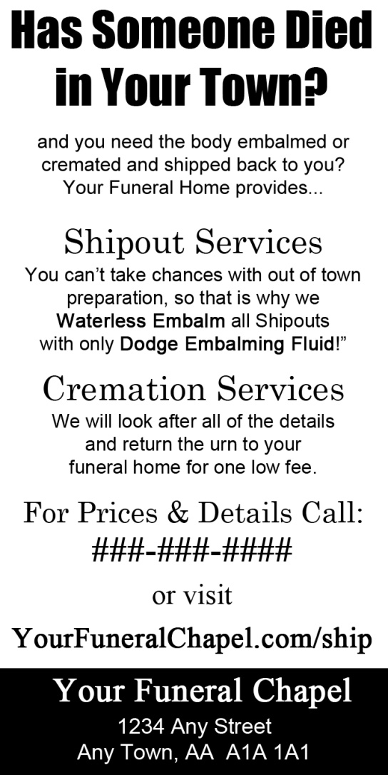

Sample Monument Yellow Pages Ad
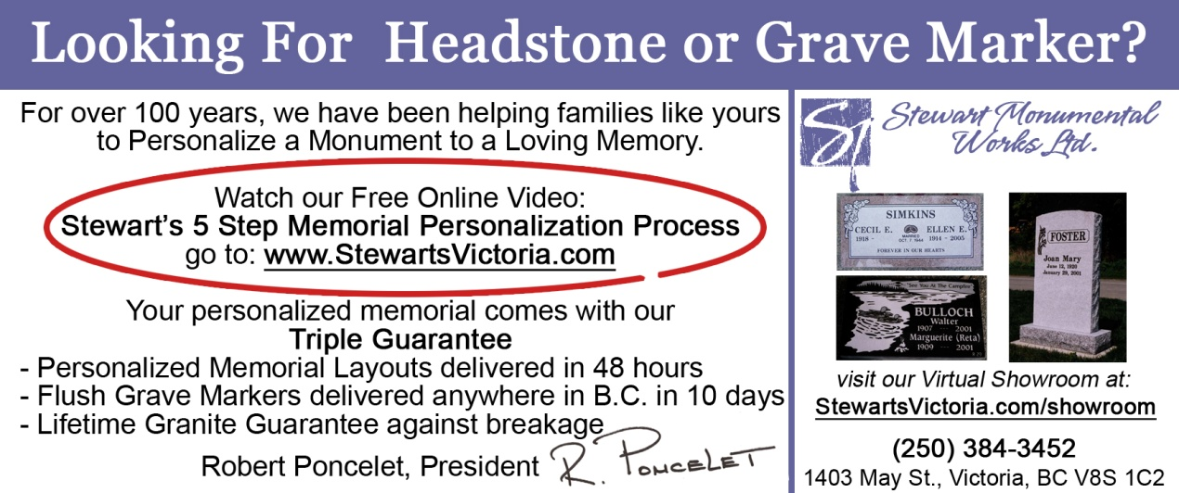

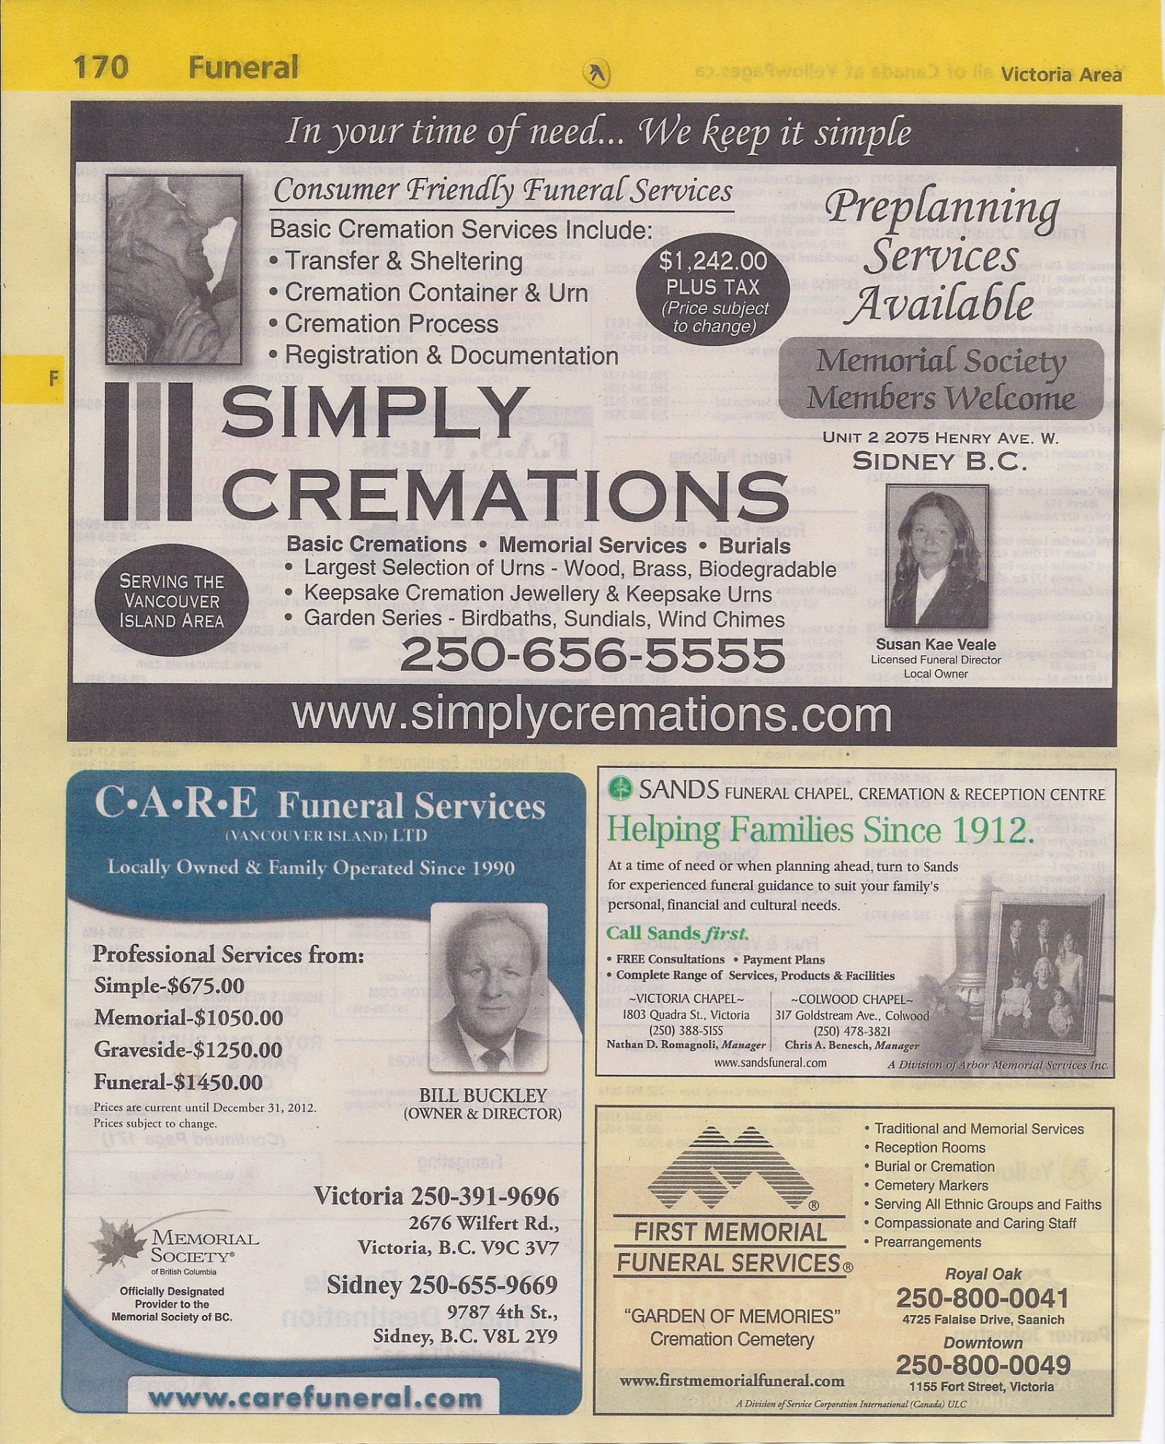
Yellow Page Ad Makeover
Yellow Page Ad Makeover

3 Funeral Website & Obituary Traffic Strategies - Swipe Copy
Here are the exact templates that I have used with many clients to increase their traffic to their websites exponentially.

1. After Arrangement Email - Send Immediately to family once obit is approved
Subject: Obituary for [First Name] [Last Name]
Dear [Family Member],
I have uploaded your [Dad’s] obituary notice to our website at
http://www.YourFuneralChapel.com/john-doe
Feel free to forward this email to friends and family as we have found that it is an easy way to let a lot of people know about service times - especially on such short notice. Let me know if you need help with anything else.
Sincerely,
[Funeral Director]
2. Email to Church & Groups - Send Immediately after email is sent to family
Subject: Obituary for [First Name] [Last Name]
Dear [Church / Group Name],
We are sorry to advise you that your member, [Deceased's Name] has passed away (or died) and his / her family has asked us to let you and your membership know of [Mr / Mrs Last Name]'s upcoming funeral service.
The complete obituary and service details can be found on our website at:
http://www.YourFuneralChapel.com/john-doe
Feel free to forward this email to your membership as we have found that it is an easy way to let a lot of people know about services times - especially on such short notice. Let me know if you have questions or need help with anything else.
Sincerely,
[Funeral Director]

3. Show Families how to add Obit to Facebook Page - Print the following on letterhead and explain and give to family in arrangement conference.
There are 5 simple steps to add an Obituary Link to Facebook:
- Go to the page where the obituary is for your loved one or friend
- Copy the web page URL (address) from the Address Bar in the top of the Browser
  - Select the address and then Copy it “Ctrl + C”
  - This is an example of what the Address looks like:
  - http://www.mccallbros.com/wm-dwight-egan-of-portland/
- Log into Facebook and press the “Update Status” at the top
- Paste the link into the box
- Select the appropriate picture, add a comment (optional), and click "Post"

Checklist of other items to help drive funeral home website traffic
Email Signature
Social Icons on Obit
TAF (Tell A Friend) - Share Obituary
Automated Posting to Facebook
Automated Posting to Twitter
In the newspaper, "Condolences may be offered for the family at www.YourFuneralChapel.com."
Video tribute on website page with note in memorial folder
QR Codes on individual Obituary pages

Fixing Broken Hearts: Haleigh's Story...

Robin Heppell <robin@funeralfuturist.com> | Tue, Apr 24, 2012 at 8:08 AM
To: robin@heppellmedia.com
Robin...
If you have found any of my free teachings or advice helpful in the past, please continue reading...
This is my daughter, Haleigh. She is 7 years old and she is raising money for the Heart & Stroke Foundation. Every year she participates in the Jump Rope For Heart campaign.
She is really passionate about Heart Health for 4 reasons:
- When she was born, she had a hole in her heart (Ventricular Septal Defect) and had open heart surgery at just 6 weeks old. She has fully recovered and is a very energetic (sometimes too energetic) little girl as you will see from her video below.
- When she was just 14 months old, Haleigh's dad died of a heart attack at the age of 38
- 25 years ago, Haleigh's grandpa had a stroke, but due to quick action and talented heart and cardio vascular doctors, Haleigh was able to meet her grandpa 2 decades later and learn many art skills from him
- She wants to make sure that if anyone else in her family or your family ever have heart issues, that the research and doctors can prevent or heal those issues - as Haleigh says it, she wants to heal broken hearts
Haleigh has been the top fundraiser at her school for the last two years and she has increased her goal to $2,000.She has asked me to help her in her fundraising efforts. So to "encourage" my clients and subscribers to help Haleigh exceed her goal, this is what I will do for you...
Anyone who donates to Haleigh's Jump Rope For Heart campaign, you / your company will
- Have your name on Haleigh's "Heart Heroes" t-shirt that she will wear to the awards assembly - the press will probably be there too
- Have your name and "backlink" to your website on Haleigh's website (backlinks are good)
- Receive a personal thank you from me on Facebook
- Receive a personal thank you from me on Twitter
- Be listed in the thank you video that we will create and promote to be a viral video on YouTube
The deadline for donating is tomorrow, Wednesday, April 25, 2012 at midnight.
If you would like to help Haleigh, what I want you to do now is:
- watch her cute video - (you will see that she is good at her multiplication too) - http://youtu.be/JlEyxrU54vM
- go to her website and follow the instructions on "how to donate" (http://HaleighJumpsRopeForHeart.com)
- make your donation on the Jump Rope For Heart website (http://haleighjumpsropeforheart.com/donate)
- complete the Sponsor Listing form so that I know what website you want to create the link to
Thanks for taking the time to read Haleigh's campaign and thanks for being a subscriber to my website.
...Hepp
PS: Any donations made that are $20 or above will receive a tax receipt. The Heart & Stroke Foundation website accepts Visa, MasterCard and American Express.

Preneed Video Scripts
Video 1: Why do people pre-arrange their service?
Script:
[Slide 1]
Hi, this is [Your Name] and welcome to frequently asked funeral questions answered by [Your Funeral Chapel].
[Slide 2 - Short]
One question that I get asked often is Why do people pre-arrange their service?
There are three main reasons why people pre-arrange their funeral services in advance:
1st: You are able to make rational and logical decisions.
2nd: The assurance that your wishes are known and will be carried out as specified and obtain peace of mind.
3rd: It will not be a financial burden on your family.
[Slide 2 - Long]
One question that I get asked often is Why do people pre-arrange their service?
There are three main reasons why people pre-arrange their funeral services in advance:
1st: You are able to make rational and logical decisions. Saving your family the burden of having to make them under times of grief and stress.
2nd: The assurance that your wishes are known and will be carried out as specified and obtain peace of mind. You have the opportunity to discuss options with our funeral professional and also with your family, church, friends, etc.
3rd: It will not be a financial burden on your family. You can select the services and merchandise according to your wishes, spiritual beliefs and budget, either by pre-paying for the services or having the monies set aside.
[Slide 3]
For more information about Funeral Planning or to schedule an appointment to see me about pre-arranging your services, contact us at (###) ###-#### or visit us online at www.[YourFuneralChapel].com

Video 2: What is involved in making pre-arrangements?
Script:
[Slide 1]
Hi, this is [Your Name] and welcome to frequently asked funeral questions answered by [Your Funeral Chapel].
[Slide 2]
Many people wonder what is involved in making pre-arrangements?
Really, the process is quite easy, there are just four simple steps:
The 1st step is recording personal information that is required for Vital Statistics. This consists of full name, address, spouse’s name, occupation, birth date, birthplace, parent’s names and their birthplaces and your next of kin or executor.
The 2nd step is Making service choices. Funeral or memorial service, burial, cremation, entombment or transfer to another city, music selections, participants (family and/or friends) to create a meaningful service.
The next step is making specific selections. The selection of a casket or cremation container, an urn, a burial or urn vault, and a monument or memorial marker.
The last step is arranging a payment plan. The services do not have to be prepaid, but the costs will be guaranteed not to increase if payment is made at one time or by monthly payments.
Then we provide you a copy of your arrangements and we keep a copy as well in our confidential records.
[Slide 3]
For more information about Funeral Planning or to schedule an appointment to see me about pre-arranging your services, contact us at (###) ###-#### or visit us online at www.[YourFuneralChapel].com

Video 3: Why pre-arrange with [Your Funeral Chapel]?
Script:
[Slide 1]
Hi, this is [Your Name] and welcome to frequently asked funeral questions answered by [Your Funeral Chapel].
[Slide 2]
(Note: You can change this script to insert more specific differentiating factors that you have over your competition if you want)
We sometimes get asked, why should I pre-arrange with your funeral home instead of one of the other funeral homes? There are 4 main reasons why you should choose [Your Funeral Chapel] as your funeral home to make pre-arrangements.
First, it's FREE. At [Your Funeral Chapel] there is no membership fee or filing charges to record your wishes for your services.
Another reason is that [Your Funeral Chapel] is locally owned and operated, and has been serving the [Your Town] area for over [XX] years. Our qualified and experienced staff, central location, modern facilities and ample parking are important to many attending services
We are also very accommodating and we want you to feel at home or be at home. The arrangements can be made in our well appointed facilities or in the comfort of your own home
And another reason is that the “The Inflation-Proof Plan” exclusively offered by [Your Funeral Chapel]. If you are considering pre-payment of your funeral, we believe that this plan is the best funeral pre-payment plan available. “The Inflation-Proof Plan” guarantees funeral costs at today’s prices and eliminates inflation.
[Slide 3]
For more information about Funeral Planning or to schedule an appointment to see me about pre-arranging your services, contact us at (###) ###-#### or visit us online at www.[YourFuneralChapel].com.

What To Do If A Death Has Occurred
Since most deaths occur in health care institutions such as hospitals and nursing homes, the attending staff may provide you with some preliminary information. If the death occurs at home, please notify the physician or attending registered nurse (if the death was unexpected or if there are any peculiar circumstances, phone the Police immediately) . If the deceased was under hospice care at home, they should have left some basic information for you to follow. No matter what circumstance, our brief checklist will help you along the way.
First Step: Initial Contact
- Contact Doctor, Nurse, Coroner or Police if necessary
- Contact our Funeral Home by phone at «Work_Phone» – we are available 24 hours / day.
  - When you call, we will ask you these questions:
    - What is the full name of your loved one who died?
    - Where did your loved one die? And are they still at that location?
    - Who is the next of kin and what is their contact information?
    - What is your name and your contact information (if you are not the next of kin)?
    - Does your loved one have a pre-arranged funeral with our firm?
Second Step: Completing Funeral and / or Cremation Arrangements
- Set an appointment time with us for you to come to the funeral home (or we can meet you at your residence or other location if you desire) to complete the details of the arrangements.
- For the arrangement, we will ask you to have information and items that we need to complete the arrangements such as:
  - Vital Statistical information for your loved one including:
  - Date and place of birth (city and state)
  - Parents names, including mother’s maiden name
  - Marital status and spouse’s full name
  - Education information
  - Social security number
  - Veteran’s information including discharge papers / claim number
  - Pre-arrangement documentation (if applicable)
  - Cemetery lot documentation (if applicable)
  - A recent photograph
  - Clothing for your loved one
- Deciding on the location of the services – this can be at our facilities, your church or other facility that is appropriate for hosting services
- Contact the Clergy / Celebrant / Officiant who will be presiding at the service – we can also guide you if the family wishes to emcee the service
- Set the time for the service
- Choose the disposition for the deceased either burial, cremation or entombment
- Compose obituary with our assistance if you wish (there is no additional fee for this service) – the information needed includes: a photo, age, place of birth, list of surviving family members, list of predeceased family members (if desired), occupation, education, memberships, military service, hobbies and activities, the details of the service, donations to a particular charity (if desired) – again, we will help you with the obituary and post it on our website, plus submit it to any appropriate newspapers (if desired)
- Determine the number of death certificate copies that you will need and we will order them for you
- Identify family / friends to serve as pallbearers – people in poor health can be named honorary pallbearers
Third Step: After the Arrangements and Before the Service
- Prepare a list of family, friends and business colleagues to be notified – we will provide you with an email to be sent to them with all of the service and obituary information
- Notify all organizations such as church, groups and associations – we will provide you with an email for this purpose as well
- Start a notebook or list to keep a record of visitors, flowers and other gifts that are delivered to the house and funeral home – if anything is delivered to the funeral home, we will notify you right away
- People will often say, “Please let us know if there is anything that we can do” so be prepared (and don’t feel bad) to accept this generosity – make a list of items and tasks such as meals (let them know if there are any special food allergies), household duties (including cleaning or mowing the lawn) and transportation (for out of town family or friends or even picking up kids from school) – again don’t feel bad accepting this help, your friends want to help but usually don’t know what to offer
- Arrange for child care (if necessary) although we strongly suggest that all family members be present at the service
Fourth Step: After the Service
- Set an appointment with our After Care Specialist (there is no additional charge for this service) to help you get organized to settle the estate and will assist you in filling out forms and contacting the appropriate agencies, including:
- Notifying the bank of the death
- Notifying insurance companies
- Contacting the lawyer if necessary
- Cancel credit cards and driver’s license, and submit phone number to Do Not Call lists
- Create a list of people and organization to send thank you cards to – consider sending a copy of the memorial folder to those who were not able to attend the service – we will provide you with 20 thank you cards, let us know if you need more
If you have more detailed questions on what steps to take next or if you are ready for us to assist you, call «Work_Phone» any time, day or night – we are here to help you.

«First_Name» «Last_Name», Owner
«Funeral_Home»
«Email_Address»
«Work_Phone»
Funeral Planning Checklist

Recording Personal Information
(See Funeral Information Sheet)
- Full legal name
- Residence
- Date of birth
- Place of birth
- Citizenship
- Personal Health number
- Social Insurance number
- Length of time in province
- Occupation
- Business or industry
- Marital status
- Spouse’s full name
- Father’s name
- Mother’s maiden name
- Next of kin / Executor’s full name
- Next of kin’s address
- Nest of kin’s relationship
- Doctor’s name & address

Making Service Choices
- Choose a funeral home
- Set time & date of service
- Choose location of service
- Apply for burial permit
- Apply for death certificates
- Choose burial or cremation
- Request preparation and embalming
- Choose family viewing or visitation
- Decide if jewelry is to remain or return
- Supply clothing for deceased
- Select photographs to be displayed
- Select musical selections, hymns & solos
- Select scripture or literature to be read
- Compose & submit obituary
- Choose charity to direct donations to
- Display religious or fraternal items
- Arrange location & food for reception
Making Specific Selections
- Select casket or cremation container
- Select burial vault or cremation urn
- Choose cemetery
- Select burial or cremation plot
- Decide whether above or below ground
- Select memorial grave marker & inscription
- Select memorial register
- Select memorial folders & acknowledgment cards
- Choose floral arrangement

Participants
- Clergy or officiant
- Organist or other musician
- Pallbearers
- Family or friend to perform eulogy
- Family or friend to read scripture or participants

Transportation
- Transfer from place of death to funeral home
- Funeral coach
- Clergy car
- Family limousine
- Pallbearer limousine
- Funeral Escort

Documents to Locate
- Will
- Deed to cemetery plot
- Birth certificate
- Marriage certificate
- Citizenship papers
- Insurance policies
- Bank documents
- Title to property
- Vehicle ownership
- Tax returns
- Military discharge papers
People to Contact
- Extended family & friends
- Doctor (G.P. or Specialist)
- Accountant
- Lawyer
- Employer
- Insurance agent
- Creditors
- Clubs, unions & organizations
- Financial advisor / banker
- Bereavement counselor if needed

Pay for the Following Services
- Funeral service
- Cemetery plot, perpetual care & interment fees
- Grave memorial, inscription & installation
- Service participants
- Newspapers
- Death Certificates
- Flowers
- Food / catering for reception
- Hospitals
- Ambulance

Personal Data of Deceased
- Elementary school attended
- High school attended
- University attended
- Military record
- Family & professional history
- Offices or positions held
- Accomplishments: personal & professional
- Citations
- Hobbies, activities and interests
- Charities & other special requests

Please note: the preceding list is only a guideline; actual arrangements will be unique to each individual.

Funeral / Celebration of Life Planning Checklist
The First Step: Statistical Information
Deceased's Surname: |  | Given Names:
Address:
City: | State: |  | Zip:
Marital Status: |  | Spouse's Name:
Occupation: |  | Industry:
Birthdate: |  | Birthplace:
Father's Name: |  | His Birthplace:
Mother's Name: |  | Her Birthplace:
Executor: |  | Relationship:
Address:
City: | State: |  | Zip:
Phone: |  | Email:
Other Contacts: |  | Phone:
Other Contacts: |  | Phone:
Other Contacts: |  | Phone:
Doctor: |  | Phone:
The Second Step: A Time To Honor And Remember - The Service
Service Location: |  | Clergy:
Burial / Cremation / Entombment |  | Details / Location:
Circle all that apply: public visitation / private family viewing / witness cremation / reception
Music 1: |  | Music 2:
Solo: |  | Prelude / Postlude:
Eulogist: |  | Readers:
Other Participants: |  | Other Participants:
Casket: Metal / Solid Wood / Cloth / Rental |  | Urn: Bronze / Steel / Solid Wood / Ceramic
Notes:

Obituary Submission Guidelines & Suggestions

Announcement:
The formal notification of the death that states the full name; the desired phrase: died, passed way, etc.; and the date and place (city / town). The cause of death is not usually stated but may be if so desired. The date and place of birth are usually listed next.
Robinson – Jane (nee Matthews) died peacefully after a courageous battle with Cancer, on December 3, 2006 in [City, State / Prov.]. She was born on March 28, 1921 in [City, State / Prov.].

Predeceased by her husband, William in 2001; Jane is survived by her children, Patricia (Frank) Thompson, Matthew (Sally), and Peter; her grandchildren, Robin Thompson, James and Jessica Robinson; and her cat, Maddy. She will be missed by many other relatives and friends.
When Bill returned from the war, Jane and Bill were married in [City, State / Prov.] and decided to raise their family. After the children were in school, Jane returned to nursing at the Royal Jubilee Hospital. In retirement, Jane and Bill were active in their church as well as avid lawn bowlers. Her greatest pleasure was received when spending time with her family.

A celebration of Jane’s life will be held at Your Funeral Chapel, First and Main Streets, on Friday, December 8, 2006 at 2:00 pm, with Rev. George Thomas officiating. A reception will follow in the Your Funeral Tribute Center.

In lieu of flowers, donations may be made to [Charity, Address, City, State / Prov. Code].
Condolences for the family may be offered at
http://«Website_URL»

Survivor Information:
Listing the spouse, children, grandchildren, great grandchildren, nieces, nephews, in-laws, other close relatives, close friends and even pets. Predeceased relatives are usually noted before the survivors.

Biographical Information:
This will tell a little about the person's life, their, education, work, honors, hobbies, etc.

Scheduled Ceremonies:
This will give the time and location of any viewings, memorial services, scatterings or inurnments; or any other gathering you may choose.

Contributions or Flowers:
Some families request that contributions be made to a meaningful organization instead of sending flowers.

Condolences:
Add this phrase at the end of the notice to let readers know that they can submit confidential messages for the family. Through this service, we receive many messages - even from around the world.

There is no fee for our client families to have their obituary notice posted on our website.

Funeral Home Website:
http://«Website_URL»

Obits on our website allow family and friends to be notified as soon as possible and not have to wait for it to appear in the newspaper.

There is no fee for a photo to be placed on our website either. Some families choose to have a longer notice on our website with a shorter one in the newspaper to reduce costs. Use the current obits on our site as additional resources for structure & choice of words.

Local Newspaper Costs:
Text Only:
1 day -
2 days -
3 days -
Photos:
1 day -
2 days -
3 days -
These rates have been supplied to us by the [Local Newspaper]. These prices are subject to change without notice.

Emailing the Obituary:
Once you have completed the obituary notice, please email it to us at «Email_Address» so that we can add it to our website and we will forward it on to the [Local Newspaper].

Remember: Please feel free to ask us to help you compose a meaningful and personalized obituary or, we can also review or proofread your draft before you submit it to the newspaper. There are no charges for these services. Obituary notices are very personal and special records. This guide is only a suggestion on how to compose an obituary notice. There is no legal requirement as to the format or even the submission of an obituary notice. We feel that giving families the opportunity to create their own notice can be beneficial in the grieving process. We wish to let families know that we can assist in composing the notice – in whole or in part – we are always willing to help. Please call us at «Work_Phone».

«Funeral_Home»: A Celebration of One’s Life!
This worksheet should be filled in as a family group if possible. All blanks do not have to be filled in, this is only an outline and to be used as a guide to make the funeral service as meaningful as possible. Please have it ready when planning the funeral with the person conducting the service (ie. Clergy, Officiant, etc.)
Nicknames |  | (from spouse) |  | (from parents) |  | (from children)
 |  | (from grandchildren) |  | (from friends) |  | (from others)
Hobbies:
Sports:
Memberships
Clubs, etc.:
Favorites
Scriptures, |  |  |  | Books &
Poems, etc.: |  |  |  | Movies:
Hymns: |  |  |  | Music:
Vacation: |  |  |  | Retreat:
Places: |  |  |  | Places:
Clothes: |  |  |  | Outings:
Outfits: |  |  |  | Restaurants:
Other Comments:
Family and Friends Participation
Eulogy: |  |  |  | Readings:
Singing: |  |  |  | Play Music:
Other: |  |  |  | Other:

